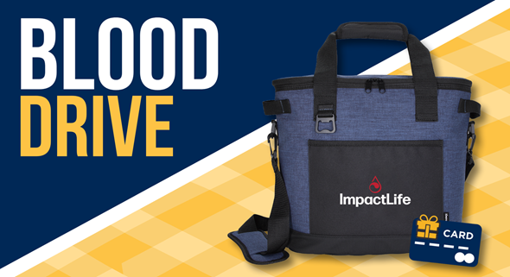

Every day, patients who need blood are in crisis and you can help by volunteering to donate. Less than 10% of the population gives blood, so your donation is very important in order to meet patient needs.

Join us for a Mt. Pulaski Community Blood Drive:

Tuesday, April 4th
2 pm – 6 pm
Bloodmobile at Longview Community Bank
130 S. Washington St., Mt. Pulaski

To schedule an appointment, call the Blood Center at 800-747-5401
or click here. Appointments required.

All presenting donors get their choice of a cooler tote or a gift card!

How much can I earn?
- $10 gift card if you are a whole blood donor (have given 2x or more before)
- $25 gift card if you are a first- or second-time donor
- $25 gift card if you are if you are a double red donor (regardless of frequency)

