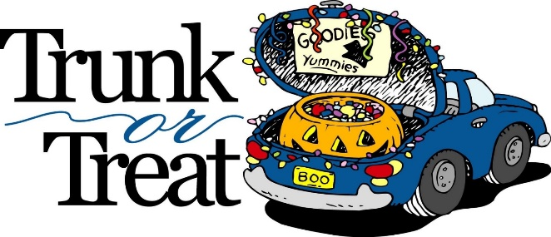
Mt Pulaski 2023 Trunk or Treat
On the Square in Mt Pulaski
Participation Form

Name/Business/Organization: ______________________________________________________
Email: ___________________________________________ Phone #:_______________________

I want to: _____ Host/Decorate a trunk – Do you need electricity for your trunk? YES NO

_____ Sponsor/Coordinate an activity
What activity? _________________________________________________

_____ Donate for prizes (costume and trunk contests)

Please drop off this form to Longview Community Bank (130 S Washington Street, Mt Pulaski, IL) or give directly to Tricia Aylesworth (or mail to 415 W Cooke St, Mt Pulaski, IL 62548).

For more information or to discuss a sponsorship of an activity or prize, please contact Tricia Aylesworth by text at (217) 737-9670 or by email to mtpulaskibusinessassociation@gmail.com.

Mt Pulaski’s 2023 Trunk or Treat will be held on Saturday, October 28 from 4 pm to 6 pm and is brought to you by the Community Association of Mt Pulaski.

